Residents want more water in Little Wall Lake

**By Anthony Capps, Ames Tribune Staff Writer**

[**acapps@amestrib.com**](mailto:acapps@amestrib.com)

**12:09 am - October 12, 2013**

[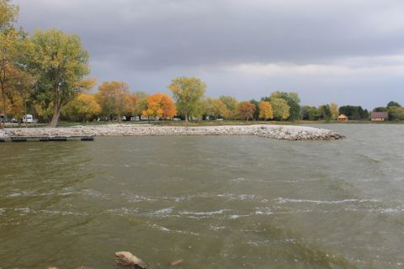](http://amestrib.com/sites/files/article/630237_web_little-wall-lake-008.jpg)

Little Wall Lake near Jewell is the focus of a dispute between local residents who want to pump water from a nearby drainage ditch into the lake to maintain its water level and the Iowa DNR, which has rejected residents’ application to do the pumping. The lake’s water level is down as a result of recent drought and lower than what local residents and visitors have become accustomed to.

[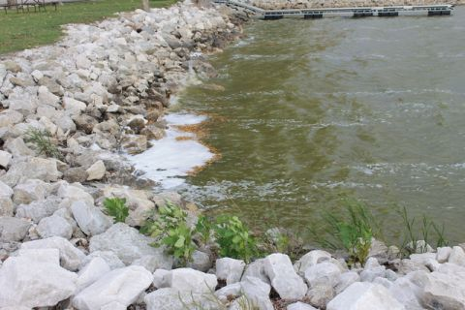](http://amestrib.com/sites/files/article/630237_web_little-wall-lake-005.jpg)

Little Wall Lake near Jewell is the focus of a dispute between local residents who want to pump water from a nearby drainage ditch into the lake to maintain its water level and the Iowa DNR, which has rejected residents’ application to do the pumping. The lake’s water level is down as a result of recent drought and lower than what local residents and visitors have become accustomed to.

[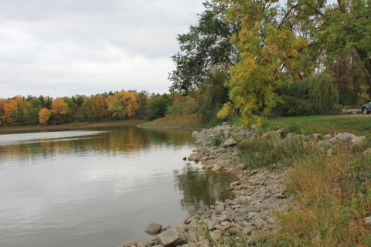](http://amestrib.com/sites/files/article/630237_web_little-wall-lake-004.jpg)[B](http://amestrib.mycapture.com/mycapture/remoteimage.asp?thumbpath=http%3A%2F%2Famestrib.com%2Fsites%2Ffiles%2Farticle%2F630237_web_little-wall-lake-004.jpg)

Little Wall Lake near Jewell is the focus of a dispute between local residents who want to pump water from a nearby drainage ditch into the lake to maintain its water level and the Iowa DNR, which has rejected residents’ application to do the pumping. The lake’s water level is down as a result of recent drought and lower than what local residents and visitors have become accustomed to. Photo by Anthony Capps/Ames Tribune

The water levels of Little Wall Lake have been on the decline with last year’s drought, and the Iowa Department of Natural Resources has denied a request by local residents to pump water from a nearby drainage ditch into the lake, leaving the future of the popular lake uncertain.

Little Wall Lake is a 250-acre recreational lake south of Jewell in Hamilton County. It is fed only by groundwater with no creek or stream emptying into it.

When the drought last year dropped its water levels, residents figured they’d have to pump water from a nearby drainage ditch. It’s been done before, and the equipment to do it is in already in place. They submitted an application to the Iowa DNR to pump water from the ditch into the lake, but the state environmental agency denied it.

While water levels at Little Wall Lake are lower than in the past, Mike McGhee, DNR lake restoration project manager, said water levels aren’t that far below the average depth, which is 6.5 feet.

Currently, the water level at Little Wall Lake is hovering around a foot below average, but for residents and those who frequent the lake and campgrounds, it’s far below the water level they’ve grown used to.

“The level of the lake is a real question because we’ve been told that the DNR has a legal limit they can fill it to,” said Jane Todey, who has lived on Little Wall Lake for 27 years. “But the lake was pumped to a higher level before, and the park’s visitors and residents have been use to those higher levels for quite a while.”

So Todey, along with other local folks, organized Friends of Little Wall Lake to bring attention to the lake’s water level and persuade the DNR to allow pumping. The group partnered with Prairie Rivers of Iowa to secure a $6,750 grant from the Enhance Hamilton County Foundation to help the effort.

Chuck Gibb, director of the Iowa DNR, assigned a working group to decide what to do at the lake and how to manage it. He also invited community members for input.

Two meetings have taken place so far — one in June and another in August — but residents are still waiting for action. Another meeting is planned for Tuesday evening at the Wallace State Office Building in Des Moines.

“We have several people telling us we can’t do this or that after something is proposed,” Todey said. “It’s not making any progress, and that’s what I thought this working group was supposed to do.”

Todey said she has continued without success to push efforts for action, including calling DNR officials and Gov. Terry Branstad.

Little Wall Lake has had problems in the past, and has gone dry from time to time.

Grass carp were added in the 1980s to battle an increasing vegetation problem, but now the DNR acknowledges the fish have eaten too much vegetation and would like to see their numbers diminish.

In 2002, a $2 million dredging took place, which loosened and removed materials from the bottom of the lake. When the DNR’s work was done, water levels in Little Wall Lake, while deeper in some spots, was lower overall than it is now.

So residents around the lake raised funds for a $30,000 three-phase electrical pump, which pumped and filtered the water from a nearby drainage ditch into the lake in 2004. It raised the water level higher than usual, and residents and visitors became accustomed to it.

The lake, which also is home to largemouth bass, bluegill, crappie, channel catfish, walleye and yellow bass fish species, is in less than idea condition.

“For fishing and water quality in general, it’s algae dominated and a turbid system,” said Scott Grummer, fisheries biologist for the DNR. “It doesn’t have very good water clarity and that situation kind of lines the problems.

“The ideal fishing would do much better with improved water clarity and some aquatic habitat.”

He said the goals for the lake include adding more vegetation to the lake, which is nearly void of plant life, something that is not uncommon for small lakes.

“Little Wall Lake isn’t reaching its potential,” he said. “We are exploring the things that could make it a target for more migrating wildlife and more enjoyable for visitors.”